*Florida International University*

*School of Computing and Information Sciences*

Software Engineering Focus

Feature Document

User Story ID 341

**Name:** Archive only "Done" documents

**Team Member(s):** Juan Hernandez

**Project:** Virtual Roll Call 4.0

**Product Owner(s)**: Jason Cohen

**Mentor(s)**: Juan Caraballo

**Instructor**: Masoud Sadjadi

**User Story Name:** Archive only "Done" documents

* Description: **As a** User **I would like** to see the documents to be archived **so that** I do not see them in the folders and they show up in the archive tab.
* This user story is defect reported by product owner

Acceptance Criteria

* Archive documents only when they are marked as “Done”.
* Documents must be older than 7 days.

**Use Case**

* Name: Archive Done Docs
* Actor: Juan Hernandez
* Preconditions:
  + Juan is logged in in the system.
  + Supervisor has uploaded a document.
* Description <Flow of events>:
  + Juan is able to see any “pending” documents on folder and also see notification icon.
  + Juan is able to see any “reviewed” documents on folder.
  + Juan is able to see any “done” documents in folder if they are younger than 7 days.
  + Juan is not able to see any “done” documents in folder if they are older than 7 days; instead, Juan is able to see them in the archive tab.

**Use Case Diagram**

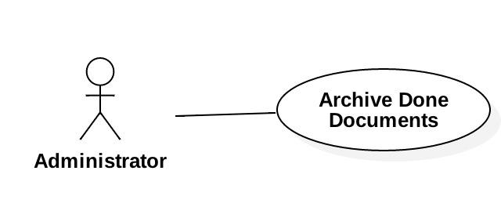

**Sequence Diagram**

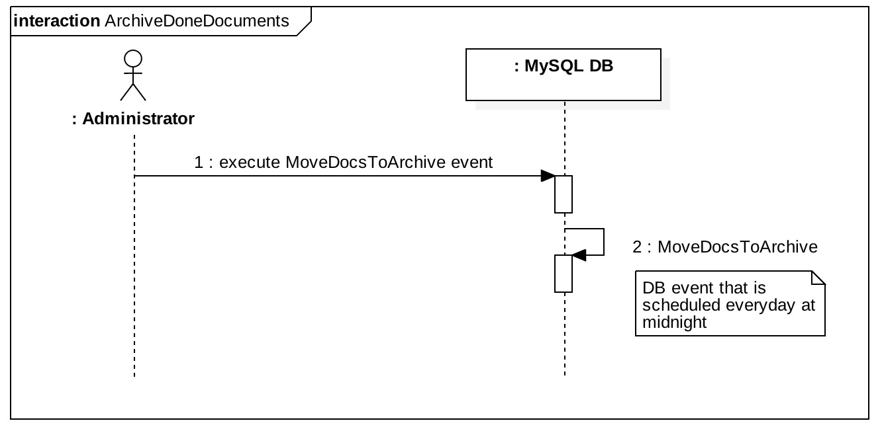

**Class Diagram**

N/A

**Unit Test**

* Test case ID: 2
* Description/Summary of Test: Documents will be uploaded. The “upload date” will be change to past 7 days old. The MySQL event will run and it will archive only the documents that are marked as “DONE”. Users must see all pending, review in the folder, and “done” document that are not older than 7 days.
* Pre-condition: Documents are uploaded.
* Expected Results: User will see the documents which are on pending or reviewed on folder, along with done document that are younger than 7 day. User will see in archive tab only the documents that are done and older than 7 day.
* Actual Result: User sawthe documents which are on pending or reviewed on folder, along with done document that are younger than 7 day. User saw in archive tab only the documents that are done and older than 7 day.
* Status (Fail/Pass): Passed

**Integration Test**

**Visual User Guide**

Documents dates:

Test1, Test2, Test3 are older than 7 days.

Test 4 is younger than 7 days.

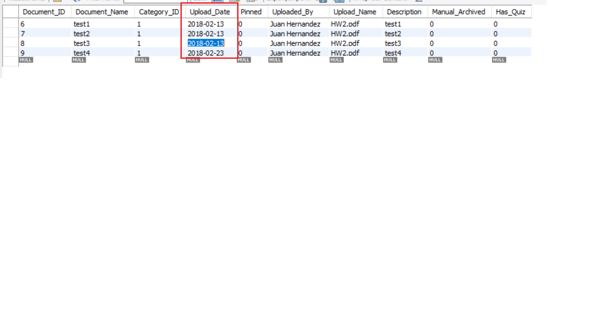

Before running MySQL event.

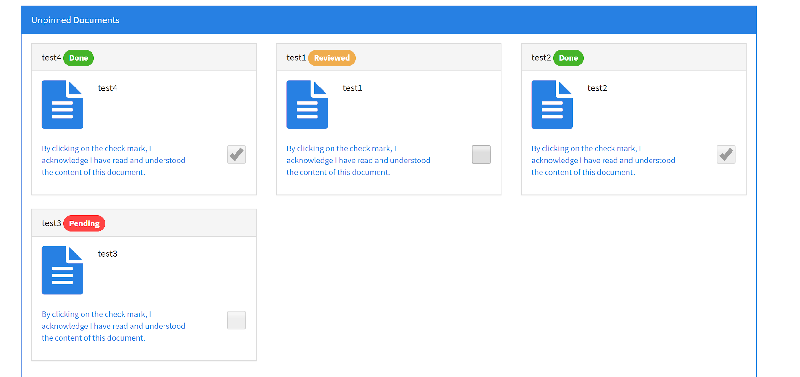

After MySQL event ran.

